Question Bank (I-Scheme)
Name of course: Electrical Circuits Unit Test: II
Subject code: 22324 (ECI) Semester: III Program: EE
Chapter 4: (Network reduction and principles of DC circuit analysis)
2 Marks
- Write the procedure of converting a current source into voltage source.
- Distinguish clearly between loop and mesh.
- Give four steps to solve mesh analysis.
- Give four steps to solve nodal analysis.
- Marks
- Using mesh analysis, find loop currents I₁ and I₂ in the circuit, as shown in Fig
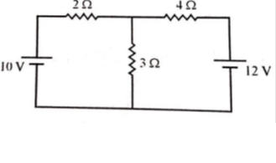
- By using Nodal analysis calculate the current in 110 Ω resistor and p.d. across
- Ω resistor as shown in fig.
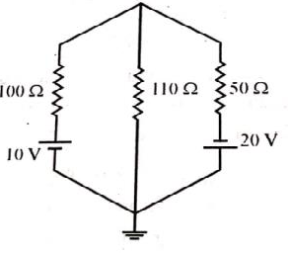
- Using Node analysis, find current I in the circuit shown in Fig.
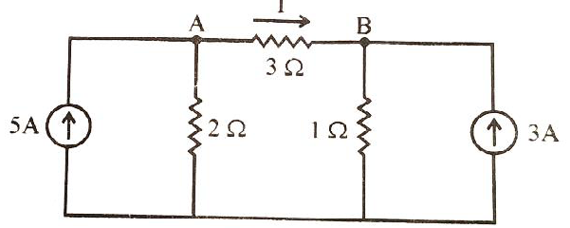

- Using mesh analysis, find current I in the circuit shown in Fig
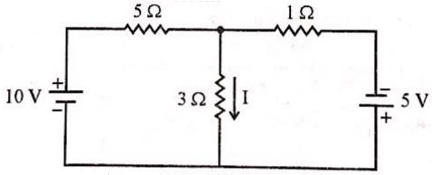

- Using mesh analysis, find current in 10Ω resistance for the given circuit.
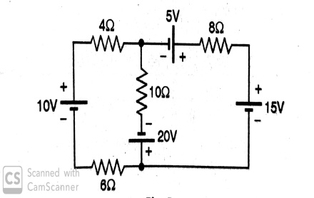
- With neat circuit diagram, explain how to convert voltage source into current source and vice-versa.
- Derive the formula for star to delta transformation.
- Derive the formula for delta to star transformation.
- Using star/Delta conversion, find the current drawn from the supply by the circuit shown in fig.
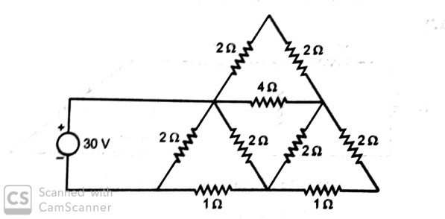
- Using Node analysis, find current I in the circuit shown in Fig.
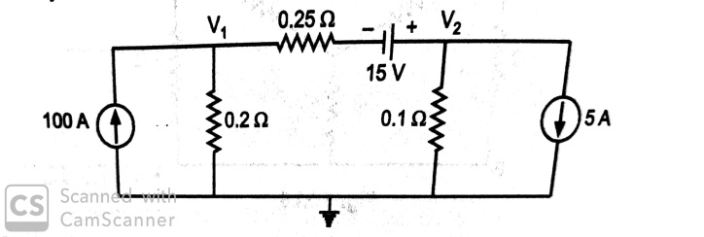
- Apply Source conversion technique for the given circuit
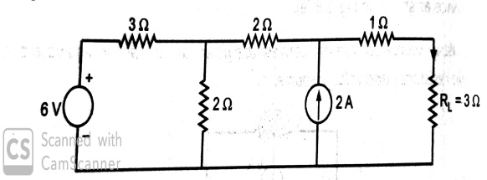

Chapter 5: (Network Theorems)
2 Marks
- State superposition theorem applied to d.c. circuits.
- State Thevenin’s theorem.
- State Reciprocity theorem.
- State the maximum power transfer theorem for DC circuit
- State Norton’s theorem.
4 Marks
- Convert following circuit as shown in figure into Thevenins circuit across A & B.
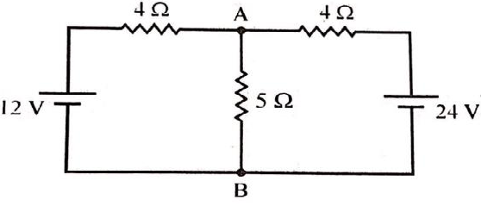
- Use Norton’s theorem to find the current through 3 Ω resistance, for the circuit shown in figure.
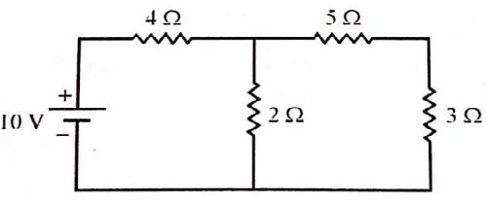

- State the Thevenin’s theorem. Also write stepwise procedure for applying Thevenin’s theorem to simple circuits.

- With neat circuit diagram, explain the concept of duality in Electric circuit. State any four examples (pairs) of duality in electric circuit.

- For network shown in Figure determine value of R so that maximum power is delivered to it. Also compute the maximum power delivered.
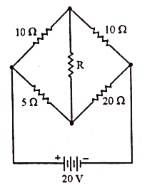

- Apply superposition theorem to compute current I in the network shown in figure
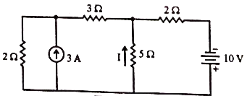

- Using Norton’s theorem, find current through 1ohm resistances in Figure
- State the superposition theorem. Also write stepwise procedure for applying superposition theorem to simple circuits.

